**Development of WING proposals for North Witney**

**Background summary**

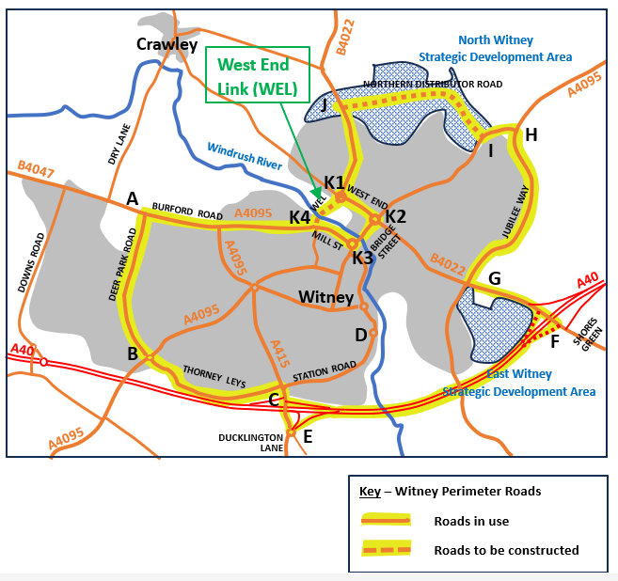Witney Infrastructure Neighbourhood Group (WING) has objected to the outline planning application for North Witney Strategic Development Area (SDA). Our report outlines our concerns and demands inclusion of appropriate infrastructure in any proposal that gains planning approval.

North Witney SDA is the final part of Witney’s long-term expansion plan for housing and associated infrastructure. Every major housing development has added a section of the perimeter road, funded by the developers. The final elements of this system are the West End Link (WEL) and the Northern Distributor Road (NDR). The Local Plan 2031 requirements are for these to be funded by the North Witney SDA developer. When this is done, it will complete an effective ring road of the town (highlighted in yellow in the plan above). This will enable traffic flow and distribution without forcing all movements to go in and out of the town centre. The current outline planning application has totally excluded proposals for the WEL and has shown a housing estate primary road in place of a distribution road for the NDR. These failures represent two of the main objections made by WING.

The Local Plan 2031 also states that the WEL could have a dual role to provide an embankment for water retention upstream of Witney as well as a highway crossing over the Windrush River. In this way, North Witney SDA could make a huge contribution to Witney’s infrastructure;

* completing the perimeter road system, and
* significantly reducing the risk of flooding in the town centre.

In addition to helping with traffic congestion and flood risk, WING’s report adds the challenge that the developer should include community infrastructure such as a community centre, shops, doctor’s surgery, schools, meeting rooms, allotments and sports facilities. The proposed development of up to 1400 houses represents a community larger than towns like Charlbury and deserves a wide range of supporting community infrastructure. WING’s case for this is detailed in our main report.

The focus of this Development Report is the potential for a dual role for the WEL. It is certain that, without infrastructure improvements, Witney will flood during periods of severe weather, and traffic congestion will get worse. The opportunity to address these problems must not be missed and development requirements must be explicitly stipulated in Local Plans.

**Involvement of Key Stakeholders**

WING comprises a group of ten local councils (nine PCs and Witney TC) who share the view that infrastructure elements of the North Witney SDA are essential. The initial version of our report was an objection to the outline planning application submitted by North Witney Land Consortium in February 2024. We then used our document for consultation with key stakeholders – OCC Highways, Environment Agency (EA) and West Oxfordshire District Council. Meetings and discussions with these organisations resulted in revision and refinement of our initial proposals and the issue of an updated report. A copy of this was submitted as an additional planning objection. (See documents within WODC Planning Application 24/00482/OUT)

In meetings the EA made us aware of options for flood retention embankments they were considering along the Windrush, between Witney and Minster Lovell. EA’s conclusion is that a total of 2 Mm3 of water needs to be retained in ponds upstream to protect Witney from a 100-year flood. Retained water can be released gradually, allowing it to pass through the town without flooding. EA have found three options for these embankments – one opposite Milking Lane retaining 0.6 Mm3, one at New Mill retaining 0.6 Mm3, and one just upstream of Dry Lane retaining 1.4 Mm3. Two of these potential options could achieve the total retention needed.

WING’s proposal for an embankment as part of the WEL crossing could replace the EA’s option for an embankment opposite Milking Lane and could be funded from developer contributions to infrastructure associated with current planning applications. WING has combined the proposal in our report with the EA Option. The resulting solution is shown here and in Detail A on the next page.

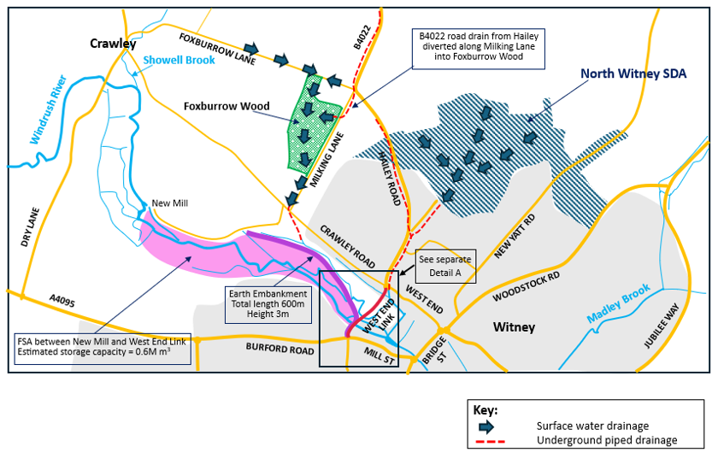

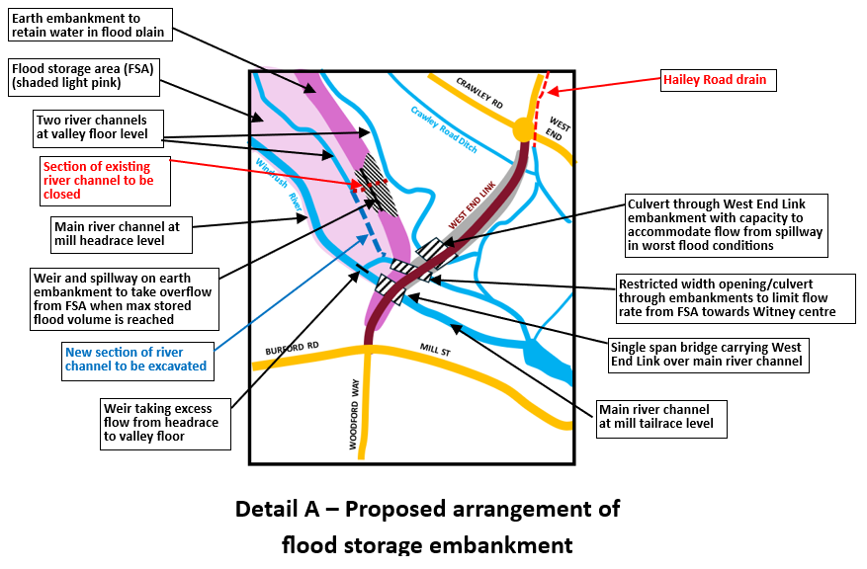The alignment of the earth embankment shown in these sketch plans allows water to be retained without interfering with the existing drains and streams on the north side of the river. Water from the north side (including Hailey Road drain) would flow freely to Bridge Street and beyond. Water would also flow along the main river channel that follows the mill race through Woodford Mill. The flow in the mill race is controlled by an existing weir that discharges excess volume into the valley floor. This water would be retained by the embankment, with discharge through a restricted opening in the embankment. The width of this opening would be designed to keep the total volume flowing towards the town centre below the maximum flow rate that can be accommodated by the bridge arches on Bridge Street.

During periods of severe rainfall, the retained volume would gradually build up until the full capacity of 0.6 Mm3 is reached. At this point the weir and spillway built on the crest of the earth embankment would begin to operate. The flow from the spillway would be taken under the WEL embankment through culverts. However, the total river flow would then exceed the capacity of the opening under Bridge Street and water would start to back up here. If this continues, there is still a risk of town flooding unless total flow is further restricted by a second embankment to retain water between Crawley and Minster Lovell. Our proposal, as set out in this report, is therefore only a partial solution for the risk of 100-year flooding. Nevertheless, it has the capacity to prevent flooding in less severe situations and to delay the impact of flooding in a 100-year situation.

**Cost Implications of WING proposals**

When construction of the WEL was first considered in Local Plans a strategic flood risk assessment (SFRA) was carried out. Options were considered for a ten-span viaduct to carry the WEL over the river valley without interfering with the river flow and for two options where combined bridge and embankment layouts were considered. These latter options caused local flooding to the properties along Crawley Road and were discounted. The SFRA concluded that a more engineered solution should be considered to find a workable flood control possibility, but this recommendation was not developed. Cost estimates were therefore limited to the multi-span viaduct solution which was seen to be expensive. The original cost estimate for the viaduct has not been updated leading to a very wide range of suggested costs. OCC have suggested costs between £35m and £50m and the developer has advised that their estimate could be as high as £80m.

WING believes that the total cost of an embankment for flood retention together with a lower embankment for the WEL highway (plus the structures as indicated in the sketch maps in this report) would be between a third and a half of the cost of the original ten-span viaduct.

**Conclusions**

Reference has been made in this report to the completion of a long-term development plan for Witney that would create a perimeter road infrastructure system to address traffic congestion in the town. WING believes that this could still be achieved using funding from North Witney SDA. However, development never stands still and there is already pressure for more housing to be added. Unless the WEL is constructed, Witney’s traffic problems will be substantially increased by the additional volume of traffic that is generated by North Witney. If the next series of housing developments is added, the situation without another river crossing would become unworkable.

Witney will also continue to flood unless flood mitigation measures are constructed. Two embankments are needed to give Witney full flood protection. The approach as set out in this report would provide the first of these embankments with substantial flood mitigation. This could be funded by developers.

WING strongly urges WODC to proceed with a dual role for the WEL that would provide both highway crossing and flood mitigation. Local Plan updates and planning approvals should retain very explicit conditions to achieve this outcome.

For Witney Infrastructure Neighbourhood Group (WING)

Mark McCappin

[mark.mccappin@crawleyvillage.org.uk](mailto:mark.mccappin@crawleyvillage.org.uk)

Graham Knaggs

[grahamknaggs@haileyparishcouncil.gov.uk](mailto:grahamknaggs@haileyparishcouncil.gov.uk)

Development of WING proposals for North Witney (Issue 1)

23 May 2025