Crawley Village Community Emergency Plan

Building Community Resilience

Plan last updated on: 2nd March 2024

What is an emergency?
The UK government defines an emergency as an event or situation which threatens serious damage to human welfare, to the environment or to the security of a place in the United Kingdom. Emergencies can also affect individuals at home, for example house fires, broken down boilers, burst pipes and so on.

The Government’s guide for communities preparing for emergencies says:
“Your local emergency responders will always have to prioritise those in greatest need during an emergency, especially where life is in danger. There will be times when you may be affected by an emergency, but your life is not in immediate danger.
During this time, individuals and communities may need to rely on their own resources to ensure they are able to cope with the consequences of the emergency. Many communities already spontaneously help one another in times of need, but… those who have spent time planning and preparing for this are better able to cope, and to recover more quickly.”

What emergencies might affect Crawley?
The Thames Valley Local Resilience Forum said the most likely risks for the Thames Valley area are:
- Influenza-type disease
- River flooding
- Severe weather
- Disruption or loss of critical infrastructure – e.g. energy, water or fuel supplies or telecommunications.
- Animal disease
- Environmental pollution
- Transport accidents

The purpose of this plan is..

- To provide information and support for the emergency services, Oxfordshire County Council and West Oxfordshire District Council in the event of an emergency.
- To facilitate clear and efficient communications between residents, businesses, emergency services and other agencies during an emergency.
- To outline what support Crawley’s emergency team can safely organise for residents and businesses while waiting for emergency services to arrive, especially if they are delayed.
- To identify what resources are available to support residents and businesses during an emergency.
- To publish contact details for all people, businesses or organisations who may be able to assist in an emergency.
- To make provision to contact and support vulnerable people as appropriate during an emergency and to ensure the emergency services know where such residents are and what additional help they may require.

If you are in immediate danger, call 999

Otherwise, triggers to activate this plan are:
- When a member of the Crawley Emergency Team receives a call from the emergency services to advise us of an emergency which may need our input.
- When the Environment Agency issues a flood alert for all or part of the village.
- When the Meteorological Office issues a severe weather warning for our area.
- When a member of the Crawley Emergency Team becomes aware of an emergency by any other means.

Crawley Village Emergency Team Contact list

NAME | ROLE | TELEPHONE | EMAIL
Heather Northam | Parish Council Chair, First Aider | 07740 183051 | heather.northam@crawleyvillage.org.uk  chairman@crawleyvillage.org.uk
Colin Dingwall | Parish Councillor | 01993 706363  07980 926535 | colin.dingwall@crawleyvillage.org.uk
Mark McCappin | Parish Councillor | 01993 849655  07843 291590 | mark.mccappin@crawleyvillage.org.uk
Isabel Webb | Parish Councillor | 07502 226919 | isabel.webb@crawleyvillage.org.uk
Michelle Hill | Parish Councillor | 07391 059744 | michelle.hill@crawleyvillage.org.uk
Sheena Derry | Clerk to Parish Council | 01993 849655  07950 015767 | sheena.derry@crawleyvillage.org.uk  clerk@crawleyvillage.org.uk

Useful contacts list

WODC general enquiries | Office hours and out-of-hours emergencies | 01993 861000
WODC Emergency Planning | Office hours and out-of-hours emergencies, ask for Emergency Planning | 01993 861000
OCC Highways | Office hours | 0345 310 1111
OCC Highways | Out of hours emergencies | Use Thames Valley Police 101 service
Joint Oxfordshire Resilience Unit | Office hours | 01865 323765
Joint Oxfordshire Resilience Unit | Duty officer for out of hours | 07771 878725
OCC Adult social and health care | Office hours | 0345 050 7666
OCC Social and health care, safeguarding | Out of hours Emergency Duty Team | 0800 833 408
Environment Agency | Incident hotline | 0800 807 060
Environment Agency | Floodline | 0845 988 1188
Thames Water | No water or water leaks  24-hour hotline | 0800 316 9800  08459 200 800
Electricity | SSE Power cuts and emergencies | 105
Gas | National Gas helpline for emergencies or leaks | 0800 111 999
Witney Community Hospital |  | 01865 904222
John Radcliffe Hospital |  | 0300 304 7777
Thames Valley Police | Non-emergency number (when 999 is not appropriate)  Textphone service | 101  18001 101
BBC Radio Oxford | Main switchboard | 03459 311 111
RSPCA | Abingdon, office hours  Emergency number | 07887 475401  0300 1234 999
DEFRA | Rural Services Helpline (for farming-related advice) | 03000 200 301

Key locations for refuge

There are no suitable public buildings in the village which could be used for refuge. If anyone needs or knows of someone who may need a place of refuge during an emergency, please contact either the emergency services, the Joint Oxfordshire Resilience Unit, or one of the Crawley Emergency Team, depending on the severity of the situation – all numbers are given in the contacts list above.

Resources
RESOURCE | LOCATION | CONTACT DETAILS
Defibrillator | The Lamb Pub | Mark McCappin  07483 291590
Useful leaflets and advice from various agencies including the Environment Agency and OCC Emergency Planning | Crawley Village website, section on emergency planning | www.crawleyvillage.org.uk

Framework/ Agenda for first response decision making

Date:
Time:
Location:
Attendees:

What is the current situation?

Is an immediate response needed (eg in the case of flooding, widespread fire, widespread loss of critical infrastructure)? Or is a longer-term approach needed (eg in the case of human disease such as an influenza pandemic, or animal disease such as foot and mouth)?

Location of the emergency, especially if it involves:
- A school?
- A vulnerable area?
- A main access route?
Type of emergency
- Is there an immediate threat to life or property?
- Has critical infrastructure, e.g. electricity, gas, water or telecommunications been affected?
- Is it a longer-term issue such as an epidemic of human or animal disease?

Establishing contact with the emergency services

How can we support the emergency services?

What actions can safely be taken?

Who is going to take the lead for the agreed actions?

Are there any vulnerable people involved, and do the emergency services know where they are?
- The elderly
- Families with children
- Those with mobility or medical concerns
- Those who may not be able to understand or interpret emergency information?

What resources do we need?
- Off-road vehicles?
- Blankets?
- Food?
- Water?
- Shelter or accommodation?
- Emergency power supplies?
- Offers of support to the vulnerable?
- Support / transport for those who may have difficulty leaving their homes or places of work in the event of a need for evacuation of premises?
- Offers of support to/from farmers?

Any other issues?
Legal background including definitions

The Civil Contingencies Act of 2004 (Cabinet Office Guide) gives the following definitions.

Category 1 responders are:
- The emergency services;
- Local authorities;
- Health bodies (such as Primary Care Trusts);
- Government agencies (such as the Environment Agency).
These are required to formulate and to implement emergency plans including those for business continuity, to warn, inform and advise the public in the event of an emergency, and to communicate and co-operate with other local responders.

Category 2 responders are:
- Utilities and communications providers;
- Transport operators;
- Strategic Health Authorities;
- Government agencies such as the Health and Safety Executive).
These are required to co-operate and share relevant information with other Category 1 and 2 responders as necessary.

Category 1 and 2 responders are also required to come together to form ‘Local Resilience Forums’ (based on police force areas outside London) which will help co-ordination and co-operation between responders at the local level.

The role of the Crawley Village Emergency Team
In an emergency, the team will take the following actions.
- Ensure Category 1 responders have been alerted if appropriate.
- Use the communications cascade to establish or support communications between Category 1 and Category 2 responders and local residents and businesses.
- Co-ordinate self-help response until emergency services can respond.
- Follow the framework for first response decision-making.

Insurance
Advice from Oxfordshire County Council’s Emergency Planning Team is that anyone using tools or equipment to assist in an emergency need not worry about insurance implications provided they are competent to use the tools or equipment and do so sensibly and with due caution.

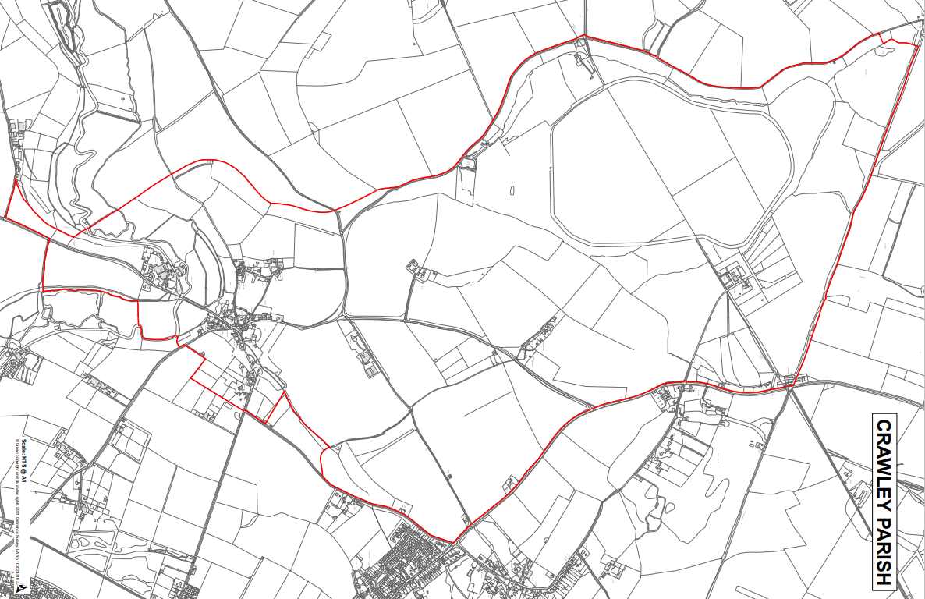
Map of Crawley Parish – boundary shown in red

