Crawley Parish Council
West End Link for Witney Flood Control
This report reviews options for flood control in Witney and concludes that the construction of the West End Link (WEL) forms a vital element in the prevention of severe flooding in the town.
Crawley Parish Council
October 2023

Page intentionally left blank

Background and Overview
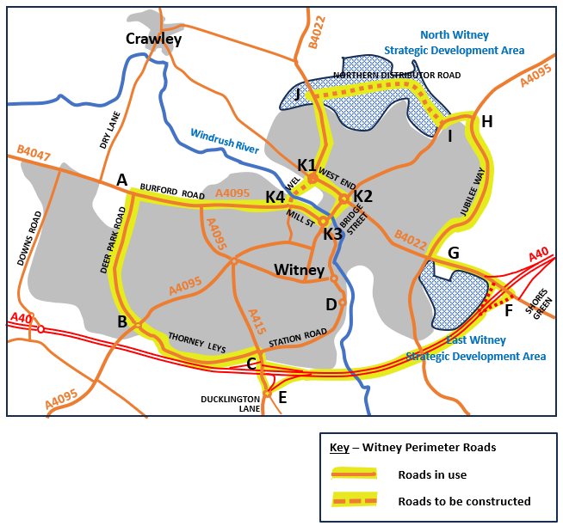
In September 2023 Crawley Parish Council (CPC) published a report (230928-CrawleyPC-Witney-Housing-Development-Report-Final.docx (live.com)) about traffic congestion and air pollution problems in Witney. We believe that these problems cannot be resolved without the construction of the West End Link (WEL). This infrastucture improvement would enable the introduction of a one-way circuit in the Bridge Street area of the town, overcoming the current bottleneck in Bridge Street and allowing traffic to flow more smoothly. Removing the queues of heavy slow-moving traffic would have a high impact in reducing air pollution. There is already a need for construction of the WEL but CPC recognises that funding has to be found first. The only apparent source is from the housing schemes in the Strategic Development Areas (SDA) in North Witney and East Witney. Our conclusion is that WODC must remain with their Local Plan 2031 commitments to complete the housing in the SDAs that will fund the remaining infrastructure developments for the WEL and the Northern Distributor Road.
Our first report focused on the issues of congestion and air pollution but we did note that construction of the WEL could also provide an opportunity to reduce the risk of flooding in Witney. This second report has been prepared to consider the flooding issues and potential solutions.
Figure 1 - Plan of Witney Perimeter Roads
Significant specialist input will be needed for the flood risk assessments and design of the WEL. CPC does not have the skills to undertake this but we do have relevant civil engineering and highway maintenance experience to draw on from our Councillors and we have tried to use common sense in our suggestions.
Working upstream, the River Windrush through Witney can be divided into a series of zones:
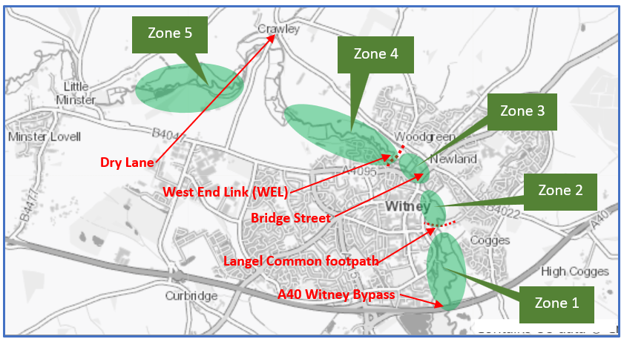
- Zone 1, from the A40 up to the footpath crossing at the downstream end of Langel Common ,
Figure 2 - Witney section of Windrush River
- Zone 2, from this footpath up to the road bridge at Bridge Street. This zone includes most of Langel Common, the bridge at New Bridge Street and the Aquarius site,
- Zone 3, from Bridge Street up to the planned position of the WEL,
- Zone 4, the floodplain area upstream of the WEL, and
- Zone 5, further floodplain area between Crawley and Minster Lovell.
In any assessment of a flooding problem, it is normal good practice to start at the downstream end. Unless there is certainty that the river flow can exit the flooded area there is no point in modifying upstream sections to increase their capacity. This will only result in worse flooding downstream.
Section 1 of this report lists the documents and sources that have been used by CPC.
Sections 2 to 6 provide detail of flooding issues and potential mitigation measures for Zones 1-5 respectively.
CPC’s conclusions and recommendations are shown in Section 7.

Reference Documents
CPC has used two key documents to help us to understand the analysis of flooding in Witney and to identify necessary actions that need to be completed to substantiate the case for construction of the WEL:
- Witney Level 2 Strategic Flood Risk Assessment (SRFA) produced for WODC by WHS Wallingford HydroSolutions Limited and issued on 20 March 2015
WODC North Witney Level 2 SFRA
- Witney Flood Investigation Report December 2020 produced by WODC and issued on 26 January 2022
WODC 2020 Flood Investigation Witney Report
We have also taken account of reports from local action groups:
- Witney Flood Mitigation Group (WFMG)
WFMG Update to WODC Sept 2021
- North Witney Action Group (NWAG)
Flooding in Witney (northwitney.org.uk)
The Strategic Flood Risk Assessment (SFRA) provided hydraulic modelling of flood levels in Witney for three construction options of the WEL:
- Option 1 – Viaduct with 9 Piers within the flood plain and clear span bridges over the existing river channels to minimise impact on flood levels (least restricted option).
- Option 2 – Raised embankment through the floodplain and clear span bridges over the three existing water courses.
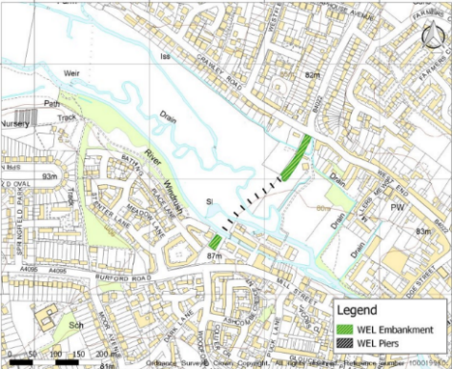
- Option 3 – Raised embankment through the floodplain and restricted bridge openings for the watercourses, to match the restricted conveyance area of the existing Bridge Street bridge in the centre of Witney.
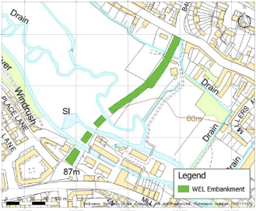
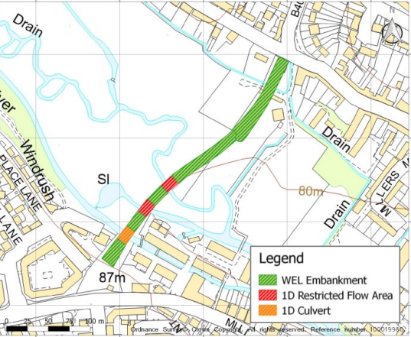

Predicted flood levels for these options taken from the SFRA are shown in Appendix A. Comment is included in Sections 4 and 5 of this report. The hydraulic modelling is based on a river model produced by the Environment Agency (EA) in 2014. This model does not include the tributaries that enter the Windrush in Witney.
There are three main tributaries; Hailey Road Drain upstream of Bridge Street, the Madley Brook in Langel Common and the Colwell Brook/Queen Emma’s Dyke system that joins the river Windrush near Ducklington. The Hailey Road Drain is culverted under Eastfield Road and Hailey Road.
It has been confirmed that an updated flood risk model for the Windrush and its tributaries through the town is to be undertaken by the EA which will include information gathered since 2014 and from the December 2020 floods.

Zone 1 – A40 to Langel Common
No flood problems are identified for this section of the river in the Level 2 SFRA and 2020 Flood Report. It is therefore assumed that flows coming through Witney will not cause flooding in the Windrush below the A40.

Zone 2 – Langel Common to Bridge Street
Flooding problems begin here with the inflow from the Madley Brook and the raised level of the Langel Common footpath. The combined effect of these is that the area becomes flooded with higher water levels backing up towards Bridge Street. Debris, silting and the lack of regular maintenance of the river channel all add to the problems.
The issues and potential solutions are described fully by WODC in the 2020 Flood Report. This is an area where WFMG have been proactive and they have contributed to the recommendations for corrective actions (See extracts from the 2020 Flood Report in Appendix B). The full list of recommended actions in WODC’s report is reproduced in Appendix C. The actions relating specifically to Zone 2 are:
Action | Lead Stakeholders | Consulting stakeholders
Update the 2014 model with updated level information, especially downstream of the Aquarius Bridge through to the footpath at Langel Common. Include main tributaries through Witney | EA | WODC, LLFA, WFMG
Investigate if the river could be modified to increase flow capacity during severe conditions, especially between New Bridge Street through to the footpath in Langel Common. | EA | Landowners, LLFA and WODC.
Investigate if the perimeter ditch of the Aquarius site can be modified/ diverted to increase flow capacity. | WODC | EA, Landowners, LLFA
Look at improving flows through Langel Common footpath to ensure flood plain connectivity is improved during all flood events. | EA | OCC, Landowners, WODC
CPC has met with WFMG and supports these actions. We agree with WFMG that corrective actions should begin at the downstream end of the river through Witney before further measures are instigated in Zones 3 and 4. It is worth noting the comment by WODC in their report that:
“It is not clear from the modelling if the increase in flood levels upstream of Bridge Street are caused by the Bridge itself or the capacity issues downstream.”
CPC believe that the bridge in Bridge Street will remain as the controlling restriction that causes flooding in Zones 3 and 4. However, this will become clearer when downstream issues in Zone 2 have been resolved. In their update to WODC in Sept 2021, WFMG include Witney Bridge Redesign or Rebuild as one of their list of Outline Demands for the People of Witney. CPC does not agree that rebuilding the bridge is a practical or affordable option. We believe that capital funding would be much better targetted at the construction of the WEL.

Zone 3 – Bridge Street to the WEL
In severe storms, flooding in Witney will be worst in Zone 3, the central section of the town immediately upstream of Bridge Street. Flooding in this Zone might be overcome through removal of restrictions downstream of Bridge Street to maximise the flow under Bridge Street bridge. If, as CPC believes, this is insufficient to prevent flooding in Zone 3 it may then become necessary to introduce measures that will restrict the flow into the Zone. For this report, we will assume that control measures in Zone 2 have already been completed and that there are no further measures that can be taken to increase the flow under the bridge. Attention must therefore move to consider ways to reduce the inflow to Zone 3.
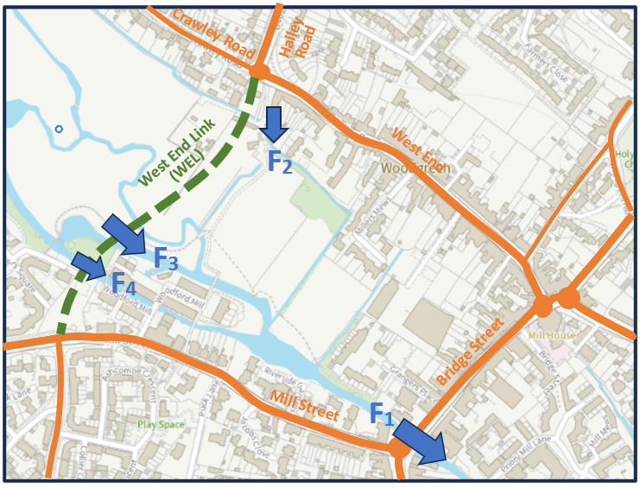
F₁ - Exit flow from Zone 3 under Bridge Street.
F₂ - Inflow to Zone 3 from Hailey Road Drain.
F₃ - Main Inflow to Zone 3 from Windrush River. Two existing channels to be combined.
F₄ - Inflow to Zone 3 via Woodford Mill millstream.
A ‘common sense’ conclusion is that, to prevent flooding in Zone 3, total (F₂ + F₃ + F₄) must not exceed F₁.
If the volume coming in to Zone 3 does not exceed the volume that can exit under Bridge Street Bridge, the problem of flooding is solved.
Figure 3 - Flows in and out of Zone 3
Flow F₂ into Zone 3
The flow that discharges from Hailey Road Drain (F₂) is made up of three parts:
- surface water from Hailey village catchment area that is drained to the B4022. This flow merges with the culverted drain from Eastfield Road and then continues in the culvert down Hailey Road Drain to the outfall at F₂,
- flow in the stream above Eastfield Road that enters the 750mm diameter culvert at the top of Eastfield Road. The culvert collects surface water along Eastfield Road and Hailey Road to the outfall at F₂,
- flow in a ditch/drain that runs along the gardens of Crawley Road properties and discharges directly to the outfall at F₂.

Taking these three parts in turn, consideration can be given to possible reductions in flow.
The contribution along the B4022 from Hailey village could be diverted via Foxburrow Wood and Milking Lane. A proposal to make this diversion was submitted to WODC by CPC and is shown in Appendix D.
The contribution that is drained through Eastfield Road could be reduced by the introduction of holding ponds and water retention features in North Witney SDA. These measures are fully described in the SFRA.
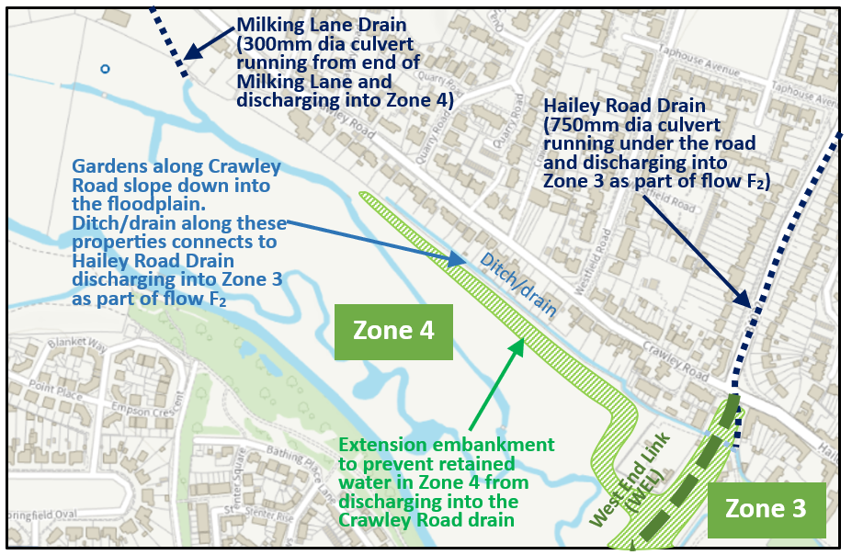
The contribution from Crawley Road properties must be retained. The affected properties are 35 houses on the south side of Crawley Road and a commercial depot in the area behind these houses, immediately adjacent to the WEL. The ditch/drain forms a vital flooding protection for these properties as shown in Figure 4 below.
Figure 4 - Flood protection for Crawley Road Properties
If the WEL is used as a dam to hold water back in the floodplain then the water level will rise above the level of the Crawley Road ditch/drain that discharges into Zone 3. To prevent this from happening an additional arm must be added to the WEL embankment as indicated in Figure 4 above. The Crawley Road properties will then be protected. Zone 4 becomes a holding pond from which water can be released into Zone 3 through the River Windrush release point (shown as flow F₃ in Figure 3).
Flow F₄ into Zone 3
This channel of the river is the millstream that runs through Woodford Mill. The flow is controlled by a wier that discharges excess water into the main river channel in the floodplain. The wier level should be set to keep the flow through the mill (F₄) at a rate that fills the millstream.

Flow F₃ into Zone 3
As explained in the paragraphs above, flows F₂ and F₄ can be limited to some extent. This leaves the control of flow F₃ as the prinicpal way to achieve the target that the total inflow (F₂ + F₃ + F₄) must not exceed F1, the flow that can exit Zone 3 at Bridge Street Bridge.
The hydraulic modelling for controlling the flow through the WEL into Zone 3 was started as Option 3 in the SFRA. WODC’s consultant, WHS, recognises that more work needs to be done on this. Their comment in the SFRA reads:
In order to further investigate the benefit of utilising the WEL bridge crossing as part of a wider flood alleviation scheme, there would be merit in investigating the viability of other more engineered flood alleviation solutions, for example:
- Re-routing of the two watercourses in the floodplain to a single, more restricted outfall point through the WEL bridge.
- Excavation within the floodplain upstream of the WEL bridge to create additional storage and wetland features.
- Provision of additional storage areas upstream of Witney. For example, WODC has previously considered storage areas in the Crawley area.
As noted in Section 1, the hydraulic modelling that was undertaken for the SFRA was based on a river model produced by the Environment Agency (EA) in 2014 that did not include the tributaries that enter the Windrush in Witney. Results of the hydraulic modelling (Options 1, 2 and 3) have been extracted from the SFRA and are reproduced in Appendix A. The EA’s model must be updated before further options can be analysed to use the WEL as embankment/dam to control flooding in Zone 3. When this is done, CPC is hopeful that a workable solution can be defined.
In contrast to this opinion, NWAG made their own assessment of the Options 1, 2 and 3 and came to the conclusion that “the proposed West End Link Road (bridge) cannot be engineered to reduce the flood risk in Witney from the River Windrush, and therefore cannot serve a ‘dual’ role”. NWAG does not appear to have realised that:
- the EA model that was used is not accurate and does not include for flow coming into the Windrush from tributaries,
- Options 1 and 2 were considering bridge/viaduct options for a river crossing that would not interfere with the flow in the river,
- Option 3 was a first attempt at considering use of the WEL as a water retaining structure to delay the flow of water into Zone 3. The flow restriction that was modelled in Option 3 was not sufficient to hold back the river flow and consequently Zone 3 still became flooded, and
- a statement was included in the SFRA that “there would be merit in investigating the viability of other more engineered flood alleviation solutions”.
CPC disagrees with the almost all the conclusions reached by NWAG on this matter. However we do agree with NWAG that properties in Crawley Road could be at risk. The embakment arm that is shown in Figure 4 is included to address the risk that NWAG identified.

Zone 4 – Floodplain above the WEL
The impact of using the WEL as a mechanism to prevent flooding in the centre of Witney will require further detailed analysis. An informed opinion can then be reached on whether there is sufficient capacity in the floodplain above the WEL to holdback the river flow and allow the retained volume to be released more slowly. The maximum extent of the lake that is formed in Zone 4 will have to be carefullly assessed to ensure that there is no harmful effect on adjacent owners. However the process of carrying out this analysis involves a series of organisations and is not wholely in the control of WODC:
- The EA must update the model of the River Windrush to include the tributaries that flow into it.
- Consultants will then have to use this model to complete a Level 3 Strategic Flood Risk Analysis. This will include further modelling of options to assess the potential benefits to the downstream flood levels, the impact of flooding to the existing Bridge Street Bridge and any consequential upstream impacts.
- Only then could a detailed design be produced for construction.
- Flood Defence Consents will have to be approved by the EA for main river sections. The River Windrush is classified as main river and hence consents will be approved by the EA. Flood Defence Consents for parts of the Hailey Road drain that are not classified as main rivers will have be approved by the Lead Local Flood Authority, Oxfordshire County Council.
- Any flood storage feature constructed with an embankment capable of holding more than 25,000m³ of water, would be subject to the Reservoirs Act 1975.
The points listed above are intended to illustrate the complexities of design requirements. CPC is well aware that this list will not be comprehensive. However we are confident that no housing developer will accept responsibility for completion and approval of the design of the WEL as a condition for planning approval of North Witney SDA. Full definition of the design brief is absent and the risks for the developer are therefore too great. WODC’s Local Plan 2031 shows that funding of the WEL will be provided from housing developments in the SDAs and there seems to be an assumption that the housing developer would fund and construct the WEL. CPC believes that a developer should only be required to provide a defined lump sum but WODC must retain responsibility for design and construction of the WEL.
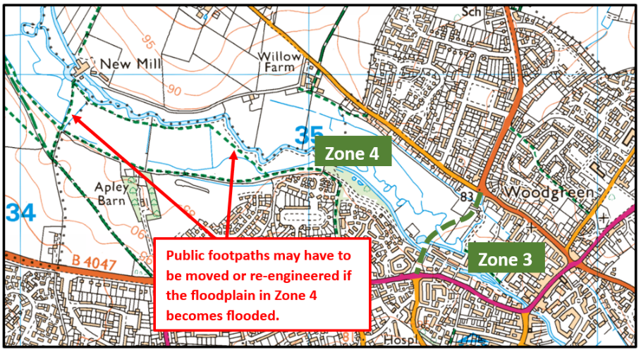
One other issue that needs to be addressed in the design for Zone 4 is the maintenance of public footpaths in the floodplain and across the river. It will be relatively easy to maintain the footpaths that run parallel to the river along the edges of the flood plain. However footpaths that cross the floodplain as indicated in Figure 5 may have to be re-engineered. The extent of this problem cannot be determined until the hydraulic modelling for using the WEL as a dam has been completed and the size of the holding pond lake is determined. Lessons can learned from the resolution of flooding at the Langel Common footpath where the path embankment has acted as a dam and caused flooding.
Figure 5 Public Footpaths in Zone 4

Zone 5 – Floodplain above Crawley
CPC does not expect flood prevention measures to extend into Zone 5 in the short-term. However we have shown the Zone in this report because of the comment in the SFRA that provision of storage areas in the Crawley area may be included as additional storage areas upstream of Witney. This would only become necessary if the WEL solution for Zones 3 and 4 proves to be insufficient to prevent flooding in Witney and an additional holding pond is needed upstream.

Crawley Parish Council’s Conclusions and Recommendations
By considering the control of flooding along the River Windrush through Witney in a series of Zones, we belive that the problems and solutions become easier to understand. Zones 1 and 5 should require no remedial action so these zones provide limits for consideration downstream and upstream respectively. The problems in Zones 2, 3 and 4 then divide into two groups; below and above Bridge Street.
The problems downstream of Bridge Street in Zone 2 must be addressed first. Only then can consideration be gven to the upstraem issues in Zones 3 and 4. Solutions for Zone 2 centre on the re-engineering of the Langel Common footpath and improvements to the management of flooding caused by the inflow of Madely Brook. There are other issues of maintenance in the main river channels through Zone 2 and these have been well documented by WODC with the assistance of WFMG.
When Zone 2 issues have been resolved, attention can turn to Zones 3 and 4. It is possible that the removal of restrictions in Zone 2 will allow more flow under Bridge Street Bridge that will overcome the problems of flooding in Zone 3. CPC believes that this is extremely unlikely and that more pro-active measures will be needed. Although some control of the flows into Zone 3 can be achieved, we think that the major control of restricting flow of the River Windrush into Zone 3 by using the WEL as an embankment/dam will be essential. There is a significant amount of design to be done before a solution can be determined with confidence. Design completion will take some time and this introduces huge uncertainty and risk for the parties involved.
What needs to be done?
Zone 2
- Langel Common footpath - design
- Langel Common footpath - construction
- Maintenance measures in river channels – design
- Maintenance measures in river channels – construction
Zones 3 and 4
- Updating the river model for River Windrush and its tributaries
- Updating Strategic Flood Risk Assessment
- Design of the WEL as an embankment/dam
- Modifications of the Hailey Road Drain to prevent overflow/flooding from the culverted section
- Construction of holding ponds and water retaining features in North Witney SDA
- Construction of the WEL
- Construction of the Northern Distributor Road

Who needs to do it?
Zone 2
- It will be a matter for WODC to decide who undertakes the design and construction of the measures in Zone 2. It seems reasonable to assume that this work could be done without the hydraulic modelling of the river being updated.
- Consideration could be made by WODC to include construction actions as planning conditions for approval of housing schemes in North Witney SDA.
Zones 3 and 4
- EA will be responsible for the update of their river model and the inclusion of the tributaries in this model. WODC should do all that they can to encourage EA to complete this task as a priority.
- WODC can then take charge of SFRA and design processes with the involvement of suitable consultants.
- WODC may consider whether to progress the diversion of the B4022 drain from Hailey and re-route this surface water via Milking Lane and Foxburrow Wood.
- Construction of the holding ponds and water retaining features that feed into the Hailey Road Drain will be part of the North Witney SDA housing contract with actions carried out by the developer.
- WODC may decide to award a separate contract for the construction of the WEL although funding may be provided as a lump sum from the SDA developer.
- Construction of the Northern Distributor Road will be an integral part of the North Witney SDA. Construction responsibilities will lie with the developer.

Who pays?
Zone 2
- It is possible that flood prevention measures in Zone 2 can be treated as part of the infrastructure improvements that are needed in Witney and funded from the housing developments in the SDAs. Decisions on this will rest with WODC.
- Consideration could be made by WODC to include construction actions as planning conditions for approval of housing schemes in North Witney SDA.
Zone 3 and 4
- Given the uncertainties over completion of the design stages, no housing developer will contemplate taking the risk of funding the WEL. However WODC may secure a defined lump sum from the developer as an alternative. Clearly it will be a difficult process to agree an estimate for the lump sum amount and WODC will probably have to use third parties to determine a figure.
- The North Witney SDA housing developer will fund the drainage measures within the SDA and the Northern Distributor Road as part of his contract.
- As noted above, the North Witney SDA developer could also be required to fund the flood improvement measures for Zone 2. A decision on this would rest with WODC.
- WODC may also consider adding a planning constraint on the East Witney SDA housing scheme to secure a lump sum contribution to the construction of the WEL. Traffic congestion issues affect the East Witney SDA as well as the North Witney SDA and the construction of the WEL is a fundamental part of addressing this problem. It would not be unreasonable to expect the East Witney SDA developer to contribute to this.

We strongly urge WODC to deliver on promises within the Local Plan and to complete the final infrastucture improvements of WEL and the Northern Distributor Road. If the opportunity to fund these improvements is lost then, in our opinion, WODC is accepting that Witney will continue to suffer from traffic congestion and air pollution and that, from time to time, the centre of the town will flood.

Submitted on behalf of
Crawley Parish Council

Page intentionally left blank

Option 1 was intended to show whether a bridge could be built across the river valley without affecting the risk of flooding. This 9-span bridge option was the most ‘open’ structure that was considered.
The predicted flood levels shown in the plan below demonstrate that the addition of this bridge makes no change in predicted flooding in the 1 in 100 year flood.
Areas shaded grey in the plan indicate predicted changes in flood levels of less than 10mm.

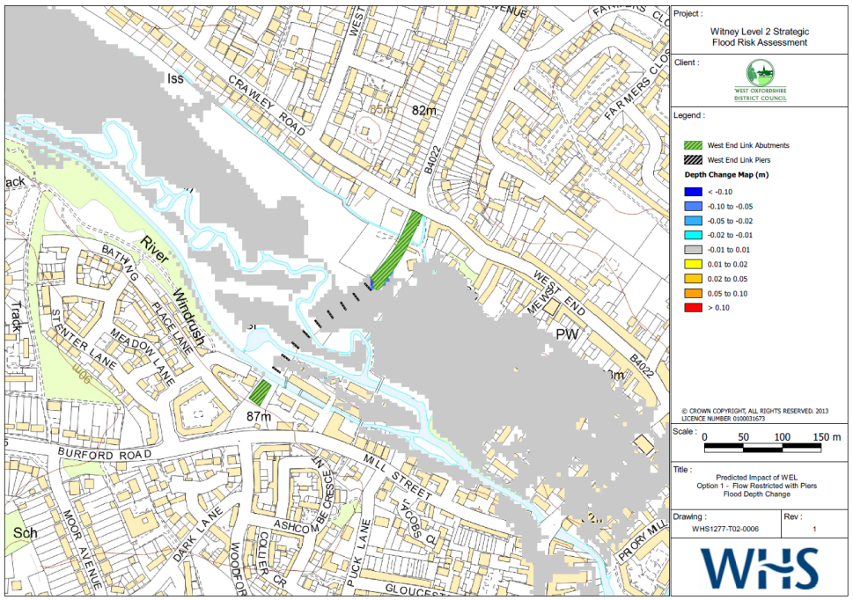
West End Link Option 1

Option 2 looked at the effect of limiting the bridge openings to three spans over the three channels of the river (1 span over the mill stream into Woodford Mill where the river is higher and 2 spans over the open river channels at the base of the valley).
Predicted flood levels were largely within 10mm of predicted flood levels without any bridge for the 1 in 100 year flood. Localised changes of up to 20mm were evident around the centre of the structure.

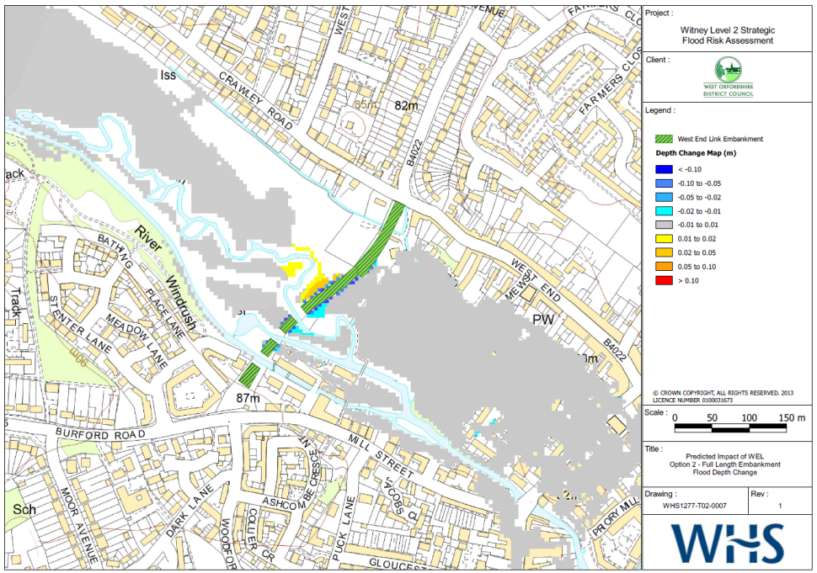
West End Link Option 2

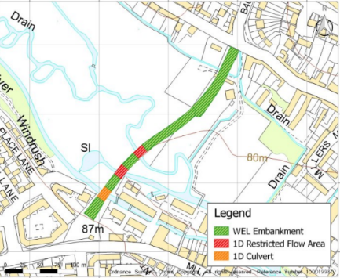
Option 3 started the consideration of options for using the West End Link as an embankment/dam that would retain water in the flood plain above the WEL and reduce flood levels in the section between the WEL and Bridge Street.
Predicted flood levels shown in the plan below indicate that some water was retained in the flood plain (areas shown yellow and red) but that the restrictions in the openings in the embankment were not sufficient to reduce the flow into Witney town centre. Flood levels here remained largely unchanged.
The flooded area upstream showed that retained water began to affect the drain/ditch in the properties along Crawley Road. If Options are considered for greater restriction of the river flow through the WEL then flood levels above the WEL will rise and the link to the Crawley Road ditch/drain will become a problem. A solution is suggested in CPC Report, Section 4, Fig 4.

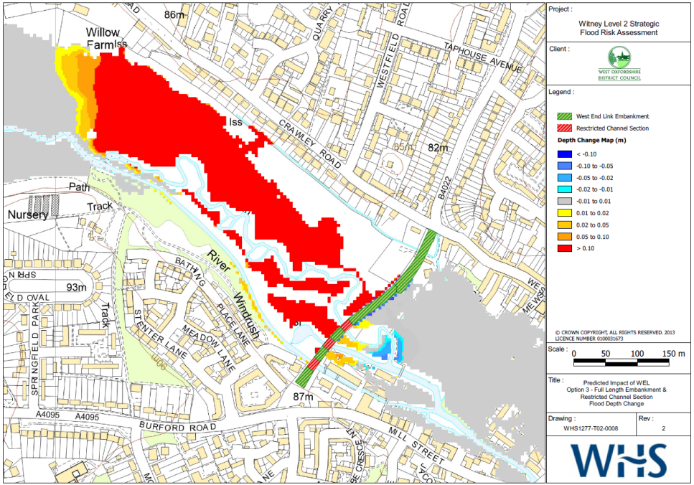
West End Link Option 3

Page intentionally left blank

Comments in relation to flooding at Langel Common are shown below:
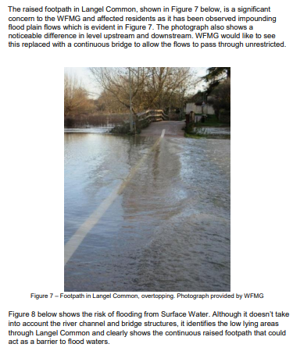
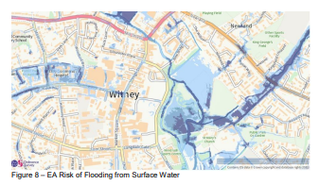

Page intentionally left blank

Full list of recommended actions taken from WODC 2020 Flood Report

Action | Lead Stakeholders | Consulting stakeholders
Communicate the explanation for the previous problems with the flood warning system and explore what further improvements and enhancements could be made. | EA | WODC, LLFA and residents.
Re-establish the Agency flood group meetings to discuss problems and to look at strategies to combat flooding due to Climate Change. Have periodic meetings with the local flood group to discuss the issues and recommendations with representatives from key authorities. | LLFA | All Authorities
Update the 2014 model with updated level information, especially downstream of the Aquarius Bridge through to the footpath at Langel Common. Include main tributaries through Witney | EA | WODC, LLFA, WFMG
Increased EA / Riparian maintenance to be carried out along the river Windrush through and downstream of Witney. Proactive visits and encouragement to ensure riparian owners carry out their duties. | EA | Landowners
Investigate if the river could be modified to increase flow capacity during severe conditions, especially between New Bridge Street through to the footpath in Langel Common. | EA | Landowners, LLFA and WODC.
Investigate if the perimeter ditch of the Aquarius site can be modified/ diverted to increase flow capacity. | WODC | EA, Landowners, LLFA
Look at improving flows through Langel Common footpath to ensure flood plain connectivity is improved during all flood events. | EA | OCC, Landowners, WODC
Install Gauge boards from Woodford Mill through to Langel Common and set up a Flood Warden network with local volunteers to record the levels during flood events. | EA | WFMG, LLFA
Look at opportunities for flood storage and increased flood plain capacity upstream of Witney and Crawley such as nature based solutions through partnership working. | EA | Landowners, LLFA, WODC
Look at opportunities for schemes to manage flows upstream of the Hailey Road drain such as nature based solutions through partnership working. | WODC | LLFA, EA Landowners, WFMG
Property flood resilience (PFR) measures which improve the resilience of the community before a flood occurs. Many properties have already carried out measures on their properties, but further funding and support may be available to help more people; | Homeowners | WODC, EA, OCC
Measures to improve the resilience of existing public or community-owned infrastructure; | All Local Government Bodies
Local community volunteer approaches to improve the community’s ability to plan, respond and recover from flooding; link to local community emergency plans; encourage affected Care Home to develop Business Continuity Plan and Evacuation Plan. | All | Communities and Residents
WODC to continue regular maintenance of their ordinary watercourse assets and use their powers under the Land Drainage Act 1991 to ensure Riparian owners carry out required maintenance. | WODC | Landowners
OCC to regularly check and maintain highway assets through Witney, in line with their current maintenance regimes. Any affected areas that haven’t been checked after December 2020 should be prioritised. | OCC Highways
Bridge Street bridge to be checked regularly and de-silting under the bridge to be carried out as and when required accepting that without de-silting being also undertaken on the upstream side of the bridge there would be little benefit to simply de-silting under the bridge. | OCC Highways | EA
Privately owned drainage systems to be checked for blockages and defects and remedial works to be carried out where necessary. Connectivity downstream to be confirmed. | Developers, Landowners | WODC, LLFA
Foul sewers to be checked for surface water connections, blockages and capacity issues. Remedial works to be carried out as necessary to minimise surface water entering the system and increase capacity. | TW | LLFA, WODC

Surface Water Drainage – North-West Witney
Flood Mitigation Proposal
This document provides an initial description of a possible scheme to address flooding problems on the B4022 at the north end of Witney. It is intended only as a consultation document to see whether it would be welcomed by the affected organisations and residents.

Problem
Current surface water drainage along the B4022 from Hailey to Witney lacks capacity to manage the flow of water following periods of heavy rain. Water gushes up from manholes along the Hailey Road and flows down the road surface to flood the area at the Hailey Road/West End roundabout.
Suggested Mitigation
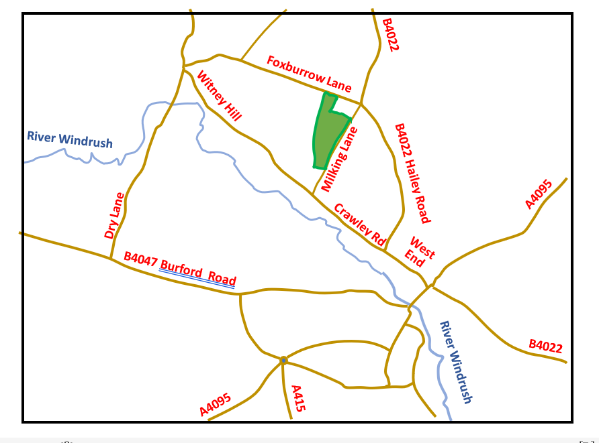
The B4022 drainage could be split at the junction of the B4022 with Foxburrow Lane. Surface water from Hailey to Foxburrow Lane could be diverted into a new drain along a short length of Milking Lane and discharged into Foxburrow Wood. The flow in the remaining section of the B4022 surface water drainage (from Foxburrow Lane Junction down to the Hailey Road/West End roundabout) would be substantially reduced, mitigating the risk of flooding.
Foxburrow Community Wood
Foxburrow Wood is managed by Wychwood Forest Trust. The trust is considering the creation of some wetland areas within the wood and may be willing and able to accommodate the surface water runoff from the northern section of the B4022.

Figure 6 - Existing Road Layout

Comment
The current and proposed drainage arrangements are indicated in Figures 2 and 3.
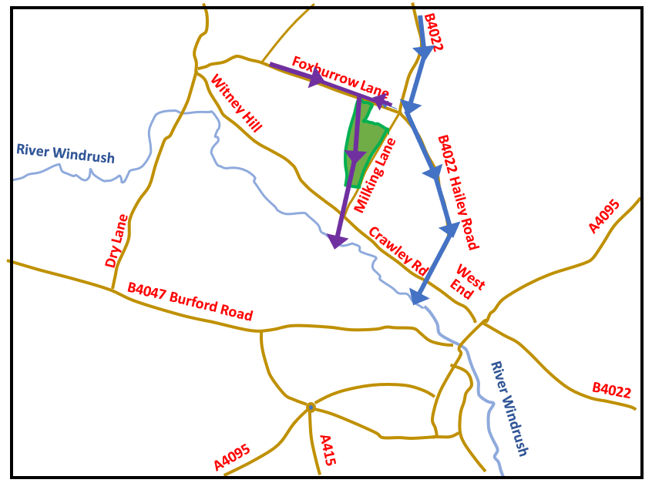
Currently the infrastructure along the B4022 appears to lack capacity. After periods of heavy rain, water runs from sections of roadside ditches, and from manholes and gullies, onto the highway. This problem may be worsened if there is housing development at North Witney and this is one of the major objections to such housing development by local residents’ groups. The proposal to divert part of the B4022 drainage via Milking Lane and Foxburrow Wood is intended to address this objection.
Only surface water from Foxburrow Lane drains though Foxburrow Wood
All B4022 drainage is taken to outfall at West End

Figure 7 - Current drainage arrangement

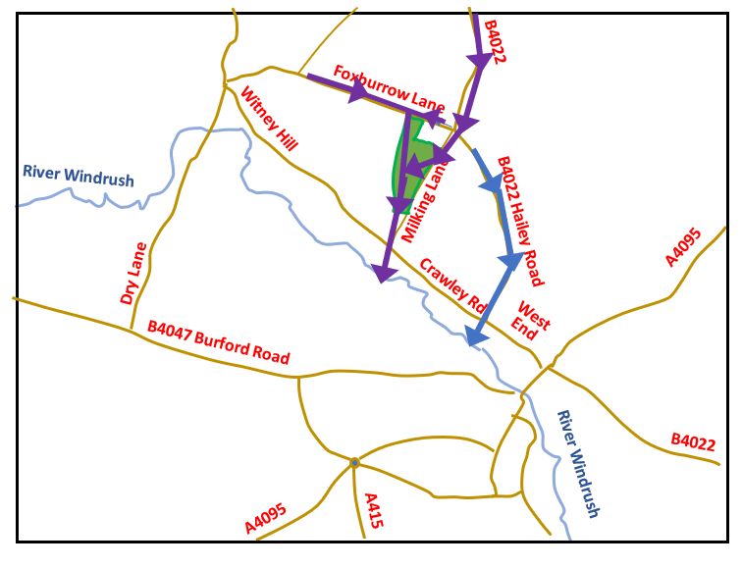
The proposed arrangement will require construction of an additional drain run along the first part of Milking Lane. Modifications of the final drain runs from the bottom of Foxburrow Wood, across Crawley Road and then to the outfall at the River Windrush may also be needed to ensure sufficient capacity.

Figure 8 - Proposed drainage arrangement

Prepared by Mark McCappin
Crawley Parish Councillor
mark.mccappin@crawleyvillage.org.uk

