|  |
| --- |
| Crawley Parish Council |
| Housing Development in Witney |
| This report highlights the need for an additional bridge over the River Windrush to mitigate existing congestion and pollution problems associated with traffic. Unless another river bridge is built, these problems will be made worse by new housing in Strategic Development Areas at North Witney and East Witney |

|  |
| --- |
| Crawley Parish Council |
| September 2023 |

Page intentionally left blank

# Congestion and Air Pollution Problems in Witney and Crawley - Overview

In the centre of Witney there is a single crossing point over the Windrush river for access into and through the town centre. The bridge on Bridge Street is a bottleneck causing congestion and delay for drivers with consequent heavy air pollution that exceeds the threshold levels set out in the Environment Act 1995. To comply with this legislation, WODC have registered the area as an Air Quality Management Area, monitored the levels of pollution, and are expected to be proactive in improving air quality. WODC recognise that relieving congestion through investment in transport infrastructure is not only important in terms of public amenity and air quality, it is also essential to unlocking future housing provision and sustainable economic growth (Local Plan 2032, paragraph 9.2.21). The specific infrastructure improvement that will have the greatest impact on reducing congestion and air pollution in Witney is the construction of the West End Link (WEL). Construction of the WEL is included in WODC’s Local Plan as an infrastructure improvement to accommodate traffic from North Witney Strategic Development Area (SDA) and to facilitate traffic movement around the town. Funding would be provided by the housing development. Crawley Parish Council (CPC) is concerned that WODC could fail to implement this aspect of the housing development and the associated infrastructure improvements.

As a result of the problems in Bridge Street many drivers are choosing to avoid Witney town centre and are seeking alternative routes. The nearest bridge over the Windrush is in Crawley where residents are suffering from a substantial increase in the volume of traffic. The construction of the WEL in Witney should discourage the innappropriate use of the narrow roads in Crawley.

The main road network around Witney comprises:

* the A40, running on a dual carriageway around the south side of the town,
* the A4095, providing a route for SW to NE movements through the town,
* the A415, catering for traffic from the south into the centre of Witney, and
* the B4022 that provides access into Witney from the north. This road extends through West End to meet the A40 at Shores Green.

Figure 1 - Area map showing impact on Crawley

At present, almost all traffic using the A4095, A415 and B4022 adds to the congestion in West End and Bridge Street. Through traffic on the A40 bypasses Witney and therefore is not a contributor to the problems in the town.

This report summarises CPC’s concerns about development plans in Witney and the consequent impacts on both Witney and Crawley. Traffic generated by the housing in the SDAs will add to congestion and air pollution in Witney and increase the traffic through Crawley. CPC’s contention is that the existing problems in Witney and Crawley already justify provision of the WEL. The infrastructure improvement should therefore be recognised as a combined solution for both current and future needs and not just a requirement for North Witney SDA.

Planning for the road layout in Witney dates back to the construction of the A40 bypass. Towns around Oxford were expanding to cater for housing needs in the county, and Witney planned for perimeter roads to facilitate traffic movements in the town. On the west and south sides, Deer Park Road and Thorney Leys were constructed (Points A, B, C on Fig 2 below). The perimeter road was then intended to proceed along Station Road, cross the Windrush river and link with Jubilee Way on the proposed Cogges Link Road (CLR) (Points C, D, G on Fig 2). The CLR and associated river crossing were lost at Public Inquiry but improvements at Ducklington Lane and the construction of west facing slip roads onto the A40 at Shores Green have enabled the southern elements of the perimeter roads to be rerouted (Points C, E, F, G on Fig 2).

Perimeter roads to the east and north of Witney will require the construction of the Northern Distributor Road (Points G, H, I, J, K1 on Fig 2). A one-way system will be established around West End, Bridge Street, Mill Street and WEL (Points K1, K2, K3, K4 on Fig 2). This will allow improved flow of traffic and reduced air pollution. The perimter road circle is completed along the B4047 Burford Road (Points K4, A on Fig 2).

Without completion of the Northern Distributor Road and WEL, Witney’s problems will persist or worsen as housing and traffic growth continues in Witney and adjacent towns. One of the two proposed new river bridges in Witney has already been lost and it is essential that WEL does not suffer the same fate.

Figure 2 - Witney Perimeter Roads

**Section 1** of this report sets out possible solutions taken from WODC’s Local Plan 2031.

**Section 2** considers the measures that are included in the Witney Air Quality Management Plan to reduce the current high levels of air pollution.

**Section 3** details the impact on Crawley from traffic using this route to avoid delays in Witney.

CPC’s conclusions and recommendations are shown in **Section 4**.

# Proposed Solutions in WODC Local Plan 2031

WODC has made a full copy of its Local Plan 2031 available at [local-plan.pdf (westoxon.gov.uk)](https://www.westoxon.gov.uk/media/feyjmpen/local-plan.pdf). The proposals for Witney housing and consequent infrastructure improvements are contained in Part 9 of the Local Plan – Strategy at the Local Level, Witney sub-area. Relevant paragraphs from this part of the Local Plan are reproduced in Appendix A.

The Local Plan 2031 records that:

Figure 3 - Witney sub-area

* the town’s single river crossing creates a ‘bottleneck’ that causes delays to journey times and poor air quality (para 9.2.10)
* infrastructure investment is essential to unlocking future housing provision (para 9.2.11)
* there is potential provision for 450 homes at East Witney SDA with funding for A40 junction improvements at Shores Green (paras 9.2.32, 9.2.33 and policy WIT1)
* there is also potential provision for 1400 homes at North Witney SDA with funding for the construction of the WEL incorporating the second river crossing for Witney (paras 9.2.37, 9.2.39, 9.2.40, 9.2.49 and policy WIT2)

If the housing developments and associated infrastructure improvements are provided fully in compliance with the Local Plan;

* congestion and air quality in the Bridge Street area will be improved;
* traffic will be less likely to use the bridge at Crawley.

However, difficulties have arisen with WODC’s position on the five-year housing land supply. Consequently, strict implementation of the Local Plan has become a matter of planning balance and judgement for the decision-maker, taking into account relevant planning considerations. The door has been opened to speculative planning applications pending the publication and adoption of an amended Local Plan. CPC’s concern is that a developer may apply to construct the North Witney housing development without inclusion of the WEL. This would have a major detrimental impact on both Witney and Crawley.

It should be noted that the original proposal for North Witney was for 1000 houses but was increased by 400 to ensure funding for the WEL and the Northern Distributor Road could be provided. The inclusion of WEL was therefore a specific condition for approval of the development.

CPC is concerned that WODC’s support for delivery of North Witney SDA in accordance with the Local Plan appears to be diminishing. A petition to abandon the housing development was presented to WODC Council in 2021 (see extracts from Council Meeting in July 2021 in Appendix B). Councillors’ comments included that:

* the petition “made no reference to where the 1400 houses should be relocated.”
* “the Local Plan could be lost and there was a danger that land would be developed anyway without the checks and balances of the Council.”
* Delivery of the North Witney SDA would provide “560 affordable homes, along with a primary school and flood prevention measures and a new road would be constructed across the river, reducing traffic and helping air quality.”

The Council resolved “That the petition be received and noted and would be considered as part of the Local Plan review.”

Objectors to WEL and North Witney SDA often state that these developments will cause severe flooding. CPC acknowledges that flood risk is a valid concern, but we are satisfied that there are robust engineering solutions that will address these concerns. Indeed, options for the form of construction of the WEL include using the WEL embankment to retain water within the Windrush flood plain. Water could be released through Witney at a rate that prevents any flooding within the town. This matter can be dealt with more fully in due course, but flood risk is not a reason to abandon long-term plans for the inclusion of North Witney SDA and the WEL.

CPC’s concern is that, if a decision is taken not to proceed with this housing development, the opportunity to fund WEL will be lost. We believe that WEL is essential for Witney and Crawley residents. Congestion and air pollution in Witney are already very serious problems.

# Proposed Solutions in WODC Witney Air Quality Management Plan

As outlined in Section 1 above, WODC’s Local Plan noted the air pollution problems in Witney confirmed that infrastructure improvements are needed, and identified specific projects that can be funded through housing development schemes. The construction of the WEL is seen as the mechanism required to tackle congestion and air pollution in the Bridge Street area of Witney.

In accordance with the Environment Act 1995, the Witney Air Quality Management Area (AQMA) was registered on 01/03/2005. The Witney AQMA is required because concentrations of nitrogen dioxide (NO2) exceed the maximum permitted levels (NO2 below 40 µg/m3). The AQMA extends the length of Bridge Street and the northern section of High Street. The concentrations of NO2 are a consequence of high volumes of traffic and congestion at the bottleneck of the river crossing at Bridge Street.  This is exacerbated by the presence of street canyons, which are stretches of road, often narrow, where there is a continuous line of buildings on either side.  This effectively traps vehicle emissions, causing a build-up within the space.

Since 2005, WODC have produced annual reports on the AQMAs in the District. The most recent report on the WODC website is [West Oxfordshire Air Quality Annual Report 2022 (westoxon.gov.uk)](https://www.westoxon.gov.uk/media/suehy0b0/west-oxfordshire-air-quality-annual-report-2022.pdf). The Conclusions and Priorities on page iv of the 2022 report state:

* This year was one of reduced travel and thus traffic-derived pollution in West Oxfordshire. Nitrogen dioxide levels in Bridge Street, Witney dropped below the national air quality objective, but were higher than those measured in 2020.
* Concentrations of NO2 have shown an increase compared to the previous year but remain lower than 2019.
* Challenges in addressing ….air quality management areas are anticipated due to the proposed and committed residential developments around… Witney. These developments will inevitably create an additional traffic burden in these areas.
* there is unfortunately no short-term solution envisaged to the problem of traffic congestion and associated vehicle emissions in Bridge Street Witney.

The reporting of air quality status uses an annual mean figure for each year. The objective target is to keep this below 40 µg/m3. Figures for the AQMAs in West Oxfordshire are shown here.

For Bridge Street Witney, the annual average result was 37.6 µg/m3 in 2021 compared to 36.8 µg/m3 in 2020.

The annualisation of results to produce a mean figure hides the peaks and troughs. The 2022 report Figures 3.1 and 3.2 shown here illustrate the effect on local (raw, unadjusted) NO2 concentrations in the District’s AQMAs as the pandemic took hold, and compare concentrations between 2019, 2020 and 2021.

Without the adjustment for annualisation, the monthly figures are in the range 35-70 µg/m3.

To address the elevated NO2 concentrations, WODC is required to develop an Air Quality Action Plan (AQAP). The plan for Witney contains 37 suggested mitigation measures which are listed, together with their anticipated effectiveness, in Appendix C of this report. WODC has tried to include as wide a range of ideas as possible. However, many of the measures are recognised as being likely to have very little impact in reducing NO2 concentrations. Taken in total, the measures may succeed in reducing air pollution slightly. However, pollution will remain dangerously high even with this reduction.

Witney needs stronger mitigation measures that will substantially reduce the air pollution levels. Only 2 of the 37 suggested measures in the AQAP are anticipated to have a high impact;

* Measure 1, Development and delivery of the Witney Area Travel Plan, and
* Measure 4, West facing slip roads at A40 Shores Green junction.

Construction of WEL is **not** included as a mitigation measure despite the recognition in the Local Plan that “... traffic flow problems … around Bridge Street …. cause delays to journey times and poor air quality” (para 9.2.10 and policy WIT2). In relation to North Witney SDA, Policy WIT2 (c) includes a requirement for “the essential delivery of the West End Link”.

As it stands the Shores Green improvements are included in the AQAP, but the WEL is not. This oversight needs to be addressed as a matter of priority.

# Traffic using Crawley as an alternative route around Witney

The nearest alternative bridge over the Windrush for Witney is on Dry Lane, Crawley, where residents already suffer heavy traffic (>3,000 vehicles/day) with long queues during peak periods. In effect, the route through Crawley operates as a perimeter road on the north and west sides of Witney. Further housing within Witney without the additional river bridge in the WEL will only make matters worse.

Motorists already use the bridge in Crawley as an alternative route (see roads shaded in pink on the map in Figure 1 above and in a larger scale version of the map that is included in Appendix D), despite the congestion hotspots that exist as follows:

* priority one-way on Leafield Road,
* alternate one-way flows with traffic light control on the bridge,
* frequent one-way flow along The Causeway on Dry Lane due to parked cars and narrow lanes,
* lengthy queues to exit Dry Lane at the T-junction with B4047 Burford Road.

Crawley residents have experienced a substantial, cumulative increase in traffic driving through Crawley made worse when the Downs Road/A40 junction was opened. The roads through Crawley are inadequate for the resulting level of traffic and for larger vehicles. Additionally, there are no footpaths within Crawley except for a small narrow section on The Causeway, placing pedestrians at increased risk when walking through the village.

# Crawley Parish Council’s Conclusions and Recommendations

**East Witney SDA**

Construction of the Shores Green west-facing slip roads onto the A40 are now certain to proceed. Funding for the highway scheme has been secured from the housing development at East Witney. However, CPC considers that some traffic from East Witney will route through the centre of Witney with a detrimental effect on both congestion and pollution. For this reason, East Witney SDA should contribute towards the construction costs for the WEL.

**North Witney SDA**

In principle, CPC would support North Witney SDA with the inclusion of the WEL as specified in the Local Plan 2031. However, CPC is concerned that WODC’s approach will open up a range of alternative outcomes, none of which would deliver the WEL.

* Inclusion of North Witney housing could be removed from the Local Plan 2041.
* Pending the completion and adoption of the Local Plan 2041, developers may submit speculative housing schemes for North Witney that do not include the WEL.
* Housing development in North Witney may be allowed to proceed on a piecemeal basis without inclusion of the larger infrastructure improvements that are needed.

CPC will campaign against the planning approval of schemes at East Witney or North Witney SDAs if they fail to fund construction of the WEL.

**Air Quality Management Plan**

WODC have monitored and reported on air pollution levels for 18 years since 2005. There is very little evidence of the introduction of active control measures that will reduce pollution.

Many of the measures included in the AQMP are recognised as having low impact on air quality. Examples include Measure 6, Reducing the Council’s fuel consumption through vehicle fleet driver awareness training, and Measure 10, Provision of secure cycle parking including covered cycle parking. The AQMP **does** include the infrastructure improvement for the A40/Shores Green west facing slip roads (Measure 4).

There is no apparent reason why construction of the WEL is not included as a measure in the AQMP which we believe must be corrected.

Opportunities to fund infrastructure improvements as listed in WODC Local Plan 2031 (para 9.2.67) are limited. The housing developments at East and North Witney may represent the last realistic opportunity to fund these much-needed infrastructure improvements. WODC did develop long term plans for infrastructure improvements around Witney that would address the huge expansion of housing in Witney as part of Oxford’s growth. This included the construction of river crossings and perimeter roads as shown in Figure 2 to facilitate traffic movement around Witney without overwhelming the centre of the town. There is still a chance to complete these plans and, in so doing, to facilitate current WODC plans for active travel and for pedestrianisation of parts of the town centre. WODC must not allow this opportunity to be lost and must remain with their Local Plan 2031 commitments to complete the housing in the SDAs and to fund the remaining infrastructure developments for WEL and the Northern Distributor Road.

Submitted on behalf of

**Crawley Parish Council**

Page intentionally left blank

Relevant parts of the West Oxfordshire Local Plan 2031 are shown below.



9.2.10 Improvements to the Ducklington Lane junction were implemented by Oxfordshire County Council in 2014 to help improve traffic flow, but problems persist in the historic core of the town around Bridge Street where the town’s single river crossing creates a ‘bottleneck’ that causes delays to journey times and poor air quality.

9.2.12 Relieving congestion through investment in transport infrastructure is not only important in terms of public amenity and air quality, it is also essential to unlocking future housing provision and sustainable economic growth.

**East Witney strategic development area (SDA) – 450 homes (Witney parish)**

9.2.32 Land to the east of Witney is allocated for the delivery of 450 new homes. The site has no significant environmental or heritage constraints, is well-located in relation to the Town Centre and provided the extent, scale and design of development is sensitively controlled, will not have a significant landscape impact. Importantly, the west facing slip roads at the Shores Green junction onto the A40 will need to be delivered alongside the development in order to help manage the impact of the development.

9.2.33 The Shores Green improvements allow traffic using the junction to travel both east and west. A financial contribution towards the slip roads has already been secured from another housing development north of Burford Road in Witney and the East Witney SDA provides another mechanism by which the slip roads can be delivered. The development itself is able to deliver the ‘off-slip’ through a planning obligation and an appropriate financial contribution will be sought towards the ‘onslip’ potentially as part of a wider strategic transport infrastructure fund/package for Witney.

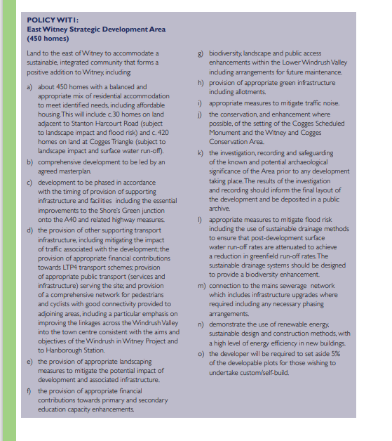

**North Witney strategic development area (SDA) - 1,400 homes (Hailey parish)**

9.2.37 Land to the north of Witney is allocated for the delivery of 1,400 homes. The site is considered to be well-related to the main services and facilities of Witney, has no major ecological or heritage constraints and based on the proposed quantum of growth, will not have a significant landscape impact. Importantly, the development will require the delivery of the West End Link (WEL) a second river crossing for Witney together with a new northern distributor road connecting Hailey Road to New Yatt Road and onto Woodstock Road.

9.2.39 The proposed site allocation comprises three separate parcels of land, a larger area of land (c. 49ha) between Hailey Road and New Yatt Road a parcel between New Yatt Road and Woodstock Road (c. 7ha) and a smaller parcel of land west of Hailey Road (c. 4ha). It is anticipated that across the allocation as a whole, around 1,400 homes could be provided.

9.2.40 The land west of Hailey Road is capable of accommodating around 100 new homes, the land between Hailey Road and New Yatt Road, around 1,100 homes and the land between New Yatt Road and Woodstock Road around 200 homes.

9.2.49 As a large site, development of the North Witney SDA is likely to fall into a number of phases. There is already a current planning application on part of the site for 200 dwellings which is likely to form ‘Phase 1’ (subject to a comprehensive masterplan/ delivery framework for the whole site). Because of the lead-in times associated with larger strategic sites, it is likely that the majority of the site will come forward later in the plan period after 2021 unless delivery can be accelerated. Delivery of the bulk of development in the medium to long-term would however offer the following advantages:

• help to ensure that housing delivery is provided evenly across the whole of the Local Plan period;

• ensure the transport impact of the scheme is minimised by allowing for the new A40/Down’s Road junction and A40/ Shores Green improvements to come forward first;

• allow time for the east and west Witney schemes to come forward in advance; and

• allow for the West End Link element of the scheme to be phased in appropriately as an integral part of the development.

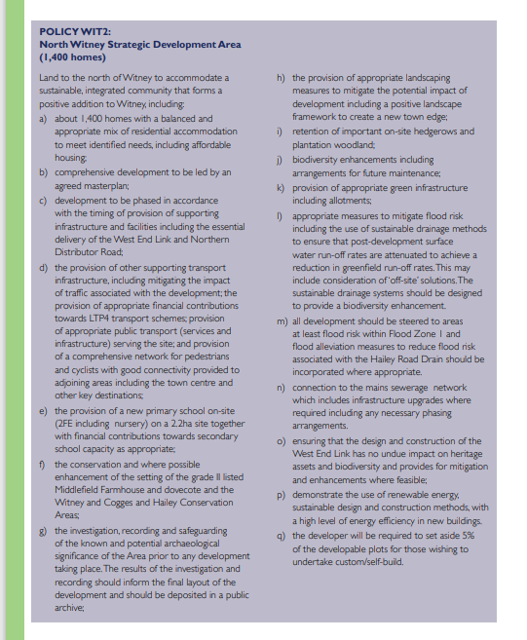

9.2.67 A number of strategic highway improvement schemes are proposed to complement the improvements that were made to the Ducklington Lane junction in 2014. These include:

• **A40/Down’s Road junction** – the provision of a new ‘all movements’ junction onto the A40 at Downs’ Road to the west of Witney. This will be delivered as part of the committed urban extension to the west of Witney (north Curbridge).

• **A40/Shore’s Green Western Slip Roads** - the provision of west facing slip roads at the Shore’s Green junction onto the A40 to the east of Witney. This will be facilitated by new development including primarily the proposed East Witney Strategic Development Area (SDA)

• **West End Link Road (WEL)** – the provision of a new road link between Woodford Way and West End creating a second river crossing for Witney. This will be facilitated by new development including primarily the proposed North Witney Strategic Development Area (SDA)

• **Northern Distributor Road** – the provision of a new road link between Hailey Road and Woodstock Road via New Yatt Road. This will be delivered as part of the proposed North Witney Strategic Development Area (SDA)

9.2.68 It is anticipated that this ‘package’ of strategic highway improvements will help to mitigate the impact of planned housing and business growth in Witney and provide a significant improvement to the flow of vehicles in and around the town. It is proposed that a strategic transport strategy and fund will be created for Witney in conjunction with the County Council as highway authority. Other ‘nonstrategic’ highway improvements will be sought as appropriate through new development including those identified in the IDP.

Page intentionally left blank

**COUNCIL**

A meeting of the Council was held in the Council Chamber, Woodgreen, Witney on Wednesday, 28 July 2021 at 2.00 pm. Included on the agenda was an item on Witney North Local Plan Housing Allocation (see item 6 below).

Cont. The agenda continued through items 7-18 (not shown here)

**WEST OXFORDSHIRE DISTRICT COUNCIL**

Extract from the Minutes of the meeting of the Council

Held in the Council Chambers, Council Offices, Woodgreen, Witney

at 2.00 pm on Wednesday, 28 July 2021

CL.19 **Petition: Witney North Local Plan Housing Allocation**   
Councillor Enright reported on the presentation of a petition calling for the reconsideration of the North Witney Local Plan Housing Allocation in the context of the information and comment contained in the report. He stated that this was a sincere effort by local residents to ask for reconsideration of the Witney North plan. He explained that the impetus for the petition had been the floods at Christmas 2020 which were in the exact area earmarked for development. Although some work was undertaken in 2007, the remedies did not work at the time. He stated that the flooding itself was a strong enough reason enough to ask the Council to consider this again. The 2007 flood was sighted as a 1 in 150-year event, but recent issues proved that this was not the case. Councillor Enright concluded by advising that sewer capacity in the region was an issue and traffic concerns from that development were stated as quite grave.

Councillor Mead proposed that the petition be received and noted and be considered as part of the local plan review. Councillor Harvey seconded the proposal.

Councillor Davies felt this was a political petition and queried if Councillor Enright had used it for re-election purposes. She believed that residents had been misled and the development could not be disposed of. She also believed that residents may have been misled as to the result of this petition being upheld.

Councillor Langridge did not agree with Councillor Davies. He felt that Councillor Enright had done an excellent job and stated that, in his opinion, the development should never have been put in the local plan. He felt that the flooding situation had worsened since the development’s inclusion, resulting in dangerous and raging torrents of water. He continued to state that the Council were planning to put 1000 homes in those areas, which would need the West End link road to work. He advised that there was no money for this but it would require a road across the floodplain, threatening floods for the whole of Oxford. He concluded by confirming that the Witney Flood Action Group felt that this development should not go ahead but Witney South or Carterton would be better locations.

Councillor Coles was saddened by Councillor Davies position. He felt that Members should respect the concerns of all residents of West Oxfordshire. He added that the petition had been started and encouraged by Councillor Enright but was supported by a large number of residents. He felt the situation had worsened and residents genuinely felt it would deteriorate further if the development went ahead.

Councillor Dingwall was pleased that the petition was going forward for consideration in the local plan. He stated that he was astonished that Councillor Enright had not learned from previous experience regarding the Coggs Link road. He went on to state that stopping that development had removed the only defence against speculative development; the result was an increase from 7600 houses to almost 16000 houses and money had to be given back to developers who had invested in the proposed development.   
Councillor Dingwall went on to state that speculative development over the last six or seven years had meant there were 500 houses in the Windrush Valley and hundreds of houses in other towns and villages around the District. He concluded by stating that the development of the Local Plan was the only defence against speculative development.

Councillor Haine directed a comment to Councillor Enright who he stated had been a member of the Development Control Committee for a long time. He reminded Councillor Enright that the Local Plan had taken a long time to get in place and Councillor Enright had made no reference to where the 1400 houses should be relocated. He felt that if this allocation was withdrawn, the Local Plan could be lost and there was a danger that land would be developed anyway without the checks and balances of the Council. A master plan of development was being drawn up with 560 affordable homes, along with a primary school and flood prevention measures and a new road would be constructed across the river, reducing traffic and helping air quality.

Councillor Acock reminded Councillor Enright that did not vote against this in 2018 when he had the chance. He echoed Councillor Davies’ comments relating to political motivation and this being for the benefit of Councillor Enright’s election to the Council.

Councillor Graham thought the points raised were interesting and reminded the meeting that flooding issues went back beyond the recent December flooding. He felt that unless infrastructure was put in place to start with, the plan was generally going nowhere. He concluded by stating that a failure to address the lack of sewers would continue to plague the area and the principle of the petition was about the people who reside in the area.

In summing up, Councillor Harvey stated that he felt Councillor Enright was wrong. He advised that it had never been assumed that the 2007 floods were a 1 in 150-year event. However, it was recorded as unprecedented for the last 150 years and it had not been suggested that it would be another 150 years before a repeat event. The Council had accepted that climate change was happening, and flood alleviation measures were continually being considered. He concluded by reminding Members that the Council had also looked at what happened in the area during the extremely cold icy winters, because climate change was occurring 12 months of the year.

Councillor Cooper asked to respond to a point raised by Councillor Haine. He stated that he had proposed an amendment to remove houses out of Witney to an alternative location, but this had been voted against. He believed scrutiny of the last Local Plan had not been good enough however he had confidence in the current Chairman of the scrutiny committee.

Having been considered and debated, the Council   
**RESOLVED**   
That that the petition be received and noted and would be considered as part of the Local Plan review.

Page intentionally left blank

The table below lists the mitigation measures from WODC’s Air Quality Management Plan (AQMP) for Witney. It also shows the anticipated effectiveness of each measure. Despite the inclusion of WEL as an essential element of the WODC Local Plan 2031, construction of this infrastructure improvement is not one of the mitigation measures.









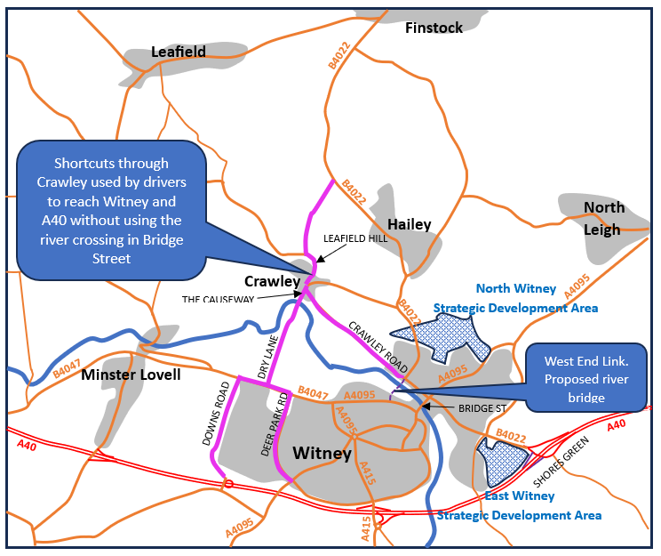

Figure 4 - Area Map indicating impact on Crawley

As a consequence of congestion and delay in the centre of Witney, drivers are choosing alternative routes to cross the River Windrush without using the single river crosssing at Bridge Street in Witney. The roads highlighted in pink on this map are the ones chosen.

* Drivers on the B4022 use Crawley to access Witney and also to link to onward routes on the A40 by using Downs Road and the recently constructed junction onto the A40.
* Within Witney, more and more drivers are using Dry Lane and Crawley Road for commuting journeys between Witney on the south of the Windrush and housing in the residential areas to the north of the river.

Construction of the WEL and the introduction of a one-way circuit along WEL, West End, Bridge Street and Mill Street would overcome the congestion and delay problems and may encourage less use of Crawley as an alternative route.