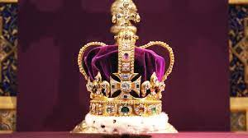
Join us for the
Crawley Village Party
celebrating the
Coronation of King Charles III
Monday May 8th 2-4 pm
Manor Farm, Farm Lane, Crawley

BBQ and other refreshments will be available free of charge. And there’ll be live music from Saxophony and Keith Harris on the keyboard. The barn will be our venue – with plenty of bunting.

If you would like to attend please RSVP by the 1st May to Michelle Hill (tel: 07391059744 or at JohnandMichelle0210@tiscali.co.uk)
or Jane Harris (at jane@jkhcommunications.co.uk)

If you have any dietary requirements please let us know so we can ensure you are catered for.

Can you help?
We’ll need plenty of garden chairs and tables. If you are able to lend us yours, please drop them off on the morning of the event.

Any cakes would also be much appreciated!

If you have some spare time and would like to volunteer to help (either in advance or at the event itself) please get in touch with Michelle or Jane.

We hope to see you there.
